Module 1: Architecture of Databricks

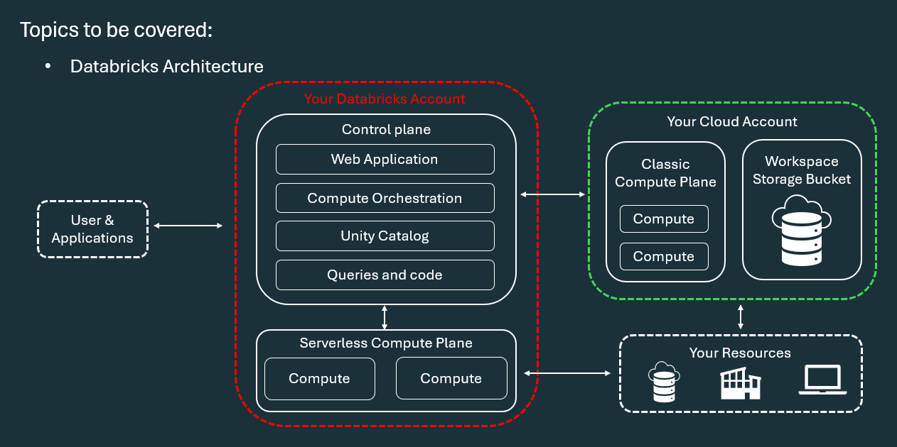

Q1: What are the two main high-level architectural layers of Databricks?

A: Databricks operates out of two main planes :
- Control Plane: Consists of backend services managed by Databricks within your Databricks account
- Compute Plane: The layer where your actual data is processed
Q2: What components reside within the Databricks Control Plane?
A: The Control Plane contains key management services, including :
- Web Application: Provides the user interface front-end for interacting with Databricks services
- Compute Orchestration: Manages the lifecycle of clusters and jobs, handling provisioning, scheduling, autoscaling, and task dependency management
- Unity Catalog & Management Services: Handles workspace management, queries, and code coordination

Q3: What key tasks are handled by Compute Orchestration in the Control Plane?
A: Compute Orchestration handles four primary responsibilities :
- Cluster Management: Ensures clusters are provisioned and terminated according to workload requirements
- Job Scheduling: Determines when and where jobs should run based on resource availability
- Autoscaling: Automatically scales compute resources up or down based on workload demand
- Task Dependency Management: Manages dependencies between tasks to ensure proper execution order

Q4: What are the two types of Compute Planes in Databricks and how do they differ?
A: The two types of compute planes are :
- Serverless Compute Plane: Compute resources run in a serverless layer within your Databricks account Databricks creates this serverless compute plane in the same cloud region (e.g., AWS region) as your workspace's classic compute plane
- Classic Compute Plane: Compute resources run directly in your own cloud storage account within each workspace's virtual network (VPC)
Q5: What is a Workspace Storage Bucket and what does it contain?
A: When a workspace is created, you provide cloud storage and a prefix to use as the Workspace Storage Bucket It contains three main categories of assets :
- Workspace System Data: Data generated by using Databricks features, including notebook revisions, job run details, command results, and Spark logs
- DBFS (Databricks File System): A distributed file system accessible via the dbfs:/ namespace (including DBFS root and mounts) Note: Storing and accessing data directly in DBFS root or mounts is not recommended by Databricks
- Unity Catalog Workspace Catalog: If the workspace is automatically enabled for Unity Catalog, it contains the default workspace catalog where all users can create assets in the default schema

